Human Evolution
Describe why humans are classified as primates
- Genetically similar depicted through related DNA
- Similarities to apes in cranial and post cranial features
- Used to be classified by physical traits however is now classified through comparison of DNA sequence and protein structure
Describe the differences between primates and human in:
- Relative size of cerebral cortex
  - The gradual increase in the size of the cranium to house a larger and more complex brain is an evolutionary trend in hominins.
  - Endocasts have been used to calculate the cranial capacity of fossilised skulls.
    - This has enabled scientists to infer that early hominins such as Australopithecus afarensis had a cranium that was much closer in size to that of modern apes than modern humans.
  - Subsequent fossil evidence confirmed a gradual increase in cranial capacity as the hominin species evolved towards modern humans.
- Mobility of the digits
  - Pentadactyl-five fingers or toes (increasing ability to move digits independently)
  - Opposable thumb/big toe (increasing thumb length/decreasing big toe opposability)
  - Nails instead of claws
  - Friction ridges for gripping

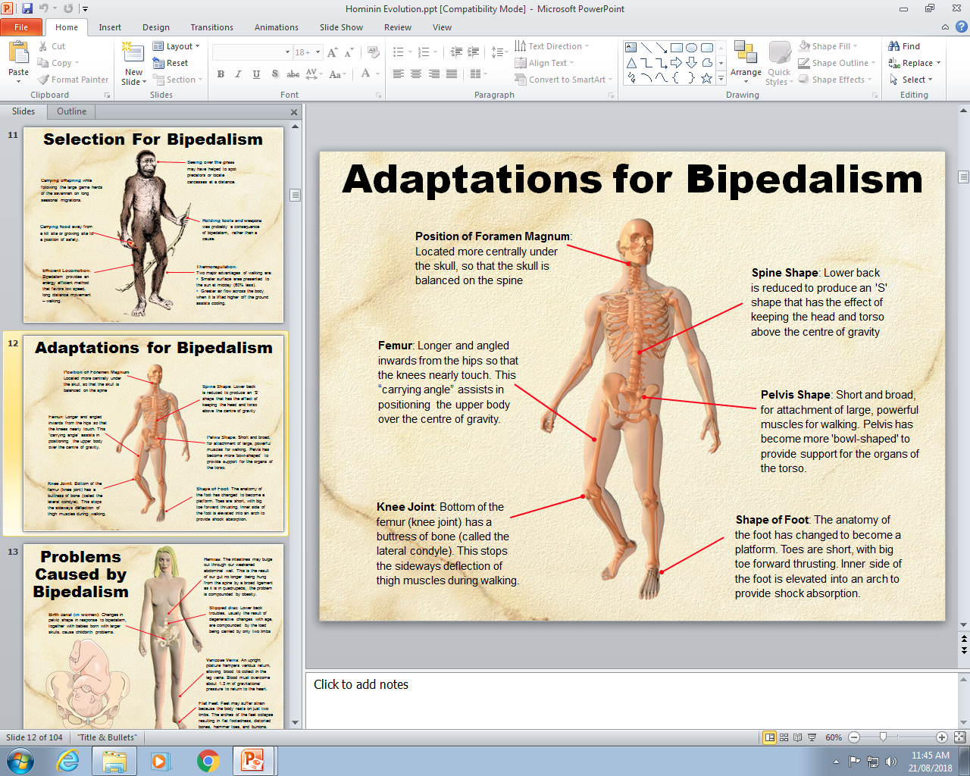
- Locomotion: adaptations to bipedalism and quadrupedal

Foramen Magnum:
  - The foramen magnum is the attachment point for the skull and the spine through which the spinal cord passes to the brain.
  - An opening close to the rear of the skull implies a quadrupedal habit of locomotion: the head is held upright by powerful neck muscles.
  - An opening located more centrally on the skull, as is found in modern humans, indicates a bipedal habit of locomotion: the head balances on the spine and less powerful neck muscles.
Spine Shape
- The lower spine has become S-shaped to accommodate the upright walking posture.
Foot anatomy
  - The human foot has undergone considerable modification to make it better suited to a walking mode of locomotion:
  - Toes became reduced in length and are no longer curved. The big toe is no longer opposable.
  - A transverse arch converts the foot into a spring allowing it to transmit the stresses of walking and improve walking efficiency
Knee Anatomy
  - modern humans, the knee joint is adapted to bear weight through the lateral condyles, which are larger than the medial condyles.
  - In chimpanzees, the knee joint is adapted to bear weight through the medial condyles.
- Prognathism and dentition
  - Prognathism extension/bulging out of lower jaw/mandible
  - Dentition teeth
    - Teeth become smaller
    - Early hominins, such as Australopithecus afarensis, had a lower jaw and face that was more like that of other apes.
      - The teeth with distinct gap between the canines and the incisors
      - The rows of teeth parallel rather than curved.
    - However, by the time of Homo habilis,
      - The molar and premolar teeth had become smaller and narrower
      - The canines were still prominent.
    - The trend towards smaller molars and a decrease in the robustness of the teeth continued in Homo erectus and is noticeable in modern humans.
    - Humans that lived about 100 000 years ago had teeth that were about 10% larger than humans of today.
    - Modern humans also appear to be gradually losing their wisdom teeth (the third molar), with an increasing number of people having no wisdom teeth at all.
  - Shape of jaw: U-shape to parabolic a shape

Create a timeline showing how human have evolved from other hominids
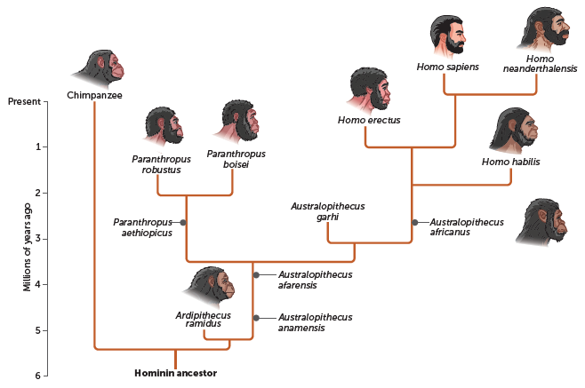
Describe evidence that suggests we are related to other hominids
- Anatomical features and habits:
  - Bipedal with modified feet, thigh bone, pelvis, and spine
  - Large cerebral cortex (forebrain)
  - Reduced canines (and teeth in general)
  - Prominent nose and chin, reduced eye ridges
  - Body hair short or very reduced to assist cooling
  - Highly sensitive skin
  - Complex social behavior
Compare the features of:
- Australopithecus Afarensis
- Australopithecus Africanus
- Paranthropus Robustus
- Homo Habilis
- Homo Erectus
- Homo Neanderthalensis
- Homo Sapiens
Australopithecus Afarensis
Other names | ‘Lucy’, ‘first family’
Known Date | 3.9-2.5 million years ago
Brain size | 400 – 500 cc
Height | 1.07 – 1.52 m
Physique | Light build  Some ape like features:  - Relatively long arms  - Curved fingers and toes  - Sexual dysmorphia
Skull shape | Ape like face  Low forehead  Bony brow ridge  Flat nose  No chin
Teeth and jaws | Human-like teeth canines smaller than apes, larger than humans  Jaw shape is halfway between that of an ape and human
Geographical distribution | Eastern Africa
Australopithecus Africanus
Other names | None
Known Date | 3.0 – 2.3 million years ago
Brain size | 400 – 500 cc
Height | 1.1 – 1.4 m
Physique | Light build  Long arms  More human features less sexual dimorphism than A. afarensis
Skull shape | - Brow ridges less prominent  - Higher forehead  - Shorter face
Teeth and jaws | Teeth and jaws much larger than in humans  Shape of jaw fully parabolic as in humans  Canine teeth further reduced
Geographical distribution | Southern Africa
Paranthropus Robustus
Other names | Australopithecus Robustus
Known Date | 2.2 – 1.5 million years ago
Brain size | 530 cc
Height | 1.1 – 1.3 m
Physique | Heavy build  Relatively long arms
Skull shape | - Long  - Broad  - Flat Face  - Crest on top of skull  - Moderate facial buttressing
Teeth and jaws | Very thick jaws  Small incisors and canines  Large molar-like premolars  Very large molars (megadont)
Geographical distribution | Southern Africa
Homo Habilis
Other names | None
Known Date | 2 – 1.6 million years ago
Brain size | 500 – 650 cc
Height | 1.0 m
Physique | Relatively long arms  Bulge for bronchus speech
Skull shape | Small face with developed nose
Teeth and jaws | Smaller, narrower molars  Thinner jaw
Geographical distribution | Eastern and southern Africa

Homo Erectus
Other names | Homo ergaster
Known Date | 1.8 – 0.3 million years ago
Brain size | 750 – 1200 cc
Height | 1.3 – 1.5 m
Physique | Robust but ‘human’ skeleton
Skull shape | - Flat, thick skull with sagittal keel  - Large brow ridge
Teeth and jaws | Smaller teeth than H. habilis  Robust jaw in larger individuals
Geographical distribution | Africa, Asia and possibly Europe
Homo Neanderthalensis
Other names | Neanderthals
Known Date | 150 000 – 28 000 years ago
Brain size | 1200 – 1750 cc
Height | 1.5 – 1.7 m
Physique | Robust but ‘human’ skeleton  Adapted to cold climates
Skull shape | - Double arched brow ridge  - High rounded orbits  - Midface projection  - Weak chin (develops)  - Long low skull  - Small mastoid process
Teeth and jaws | Similar to Archaic H. sapiens
Other names | Eastern and western Asia
Homo Sapiens
Other names | Early anatomically modern humas
Known Date | 19 500 – 60 000 years ago (for early humans)
Brain size | 1200 – 1700 cc
Height | 1.6 – 1.85 m
Physique | Modern skeleton possibly adapted for warmth
Skull shape | Small/ no brow ridge  Shorter and higher skull
Teeth and jaws | Teeth may be similar  Shorter jaws than Neanderthals  Chin developed
Other names | Africa and Western Asia (for early forms)

Summarise trends of tool use and how that links to cognitive/lifestyle development
Cultural Evolution
Homo Genus | Development of group living and culture
Homo Habilis | - Successful hunters (consumed meat)  - Food sharing  - Made shelters and lived in bands of about 12 people
Homo Erectus | - Built shelters (huts) supported by wooden poles  - Serious co-operative hunters  - Used fire  - Able to hunt large prey (rich diet led to increased size)  - Still 70% diet came from gathering
Homo Neanderthalensis | - Intelligent  - Lived in caves  - Built stone walls  - Dressed in hides  - Buried their dead  - Had strong social bonds
Homo Sapiens | - Skilled hunters  - Sewing and using and using skins for clothing/shelter  - Lived in large groups  - Engraved and painted on walls  - Carved statues

Communication
- Facial expressions important
- Speech
  - Culture requires intelligence and communication
  - Development of areas of the brain essential for structure and sense of speech
    - Broca’s area concerned with speech
    - Wernicke’s area concerned with comprehension of language
  - The lower voice box, the more sounds can be articulated
- Singing and chanting
  - Important for remembering kinship lines and tribal history
- Better hearing and listening skills as a result of speech
- Art/drawings of pictures and symbols on cave walls, bon carvings, clay statues

Use of Fire
- The earliest record of humans using fire:
  - Africa: 1.5 million years ago
  - France: 750, 000 years ago
  - China: 500, 000 years ago
- At first may have ‘captured’ from natural source bush fires caused by lightning
- Later developed techniques to create fire (friction)
- With fire early humans could:
  - Remain active at night
    - Source of light to continue their activities after dark and inside their caves
  - Cook with fire
    - Made the meat of the animals they killed more palatable and digestible
    - Learned to preserve meat by smoking it over the fire, decreasing danger of periodic starving
    - Cooking enabled them to add some formally inedible plants to their diet
  - Make better weapons and tools:
    - Hunters formed spears from tree branches by burning the tips of the branches and then scraping the charred ends to a point
  - Protect themselves from predators
  - Warmth
Home base theory
- At some sites, concentrations of tools, stones from other areas and bone are found
- Suggests that early hominins were not just carrying things around, but were focusing on one site as a home base
- Adults haunted and left the young behind, then brought all the produce back to be shared
- Sharing of food lead to complex societies
- Defined by the Homo Erectus period
Neanderthal Culture
- The Neanderthals of Europe and South-west Asia buried their dead in a way that suggests they practiced ritualised burial:
  - The grave is usually characterised by certain items found buried with the body (burnt animal bones, stone tools and flowers)
  - The position and orientation of the body are also found consistently the same (aligned east-west, with legs curled up)
- A flute-like piece of cave bear bone has been found at a Neanderthal hunting camp in Slovenia may have made music
- Creative ability was not just restricted to visual art objects music appeared to feature in Paleolithic life (flute)
- Begin to develop status

Paleolithic Art
- Modern humans underwent a culture explosion about 35, 000 years ago = rise to prehistoric art and new kinds of tools
- The stimulus was probably a need to represent in some lasting way, ideas concerned with the unknown:
  - Death
  - Hunting success
  - Fertility of their women
- Lascaux caves contain some of the earliest art, dating back to somewhere between 13, 000 and 15, 000 BC, or even as far as 25, 000 BC
Development of agriculture
- Learning to cultivate a food-producing plant; not just gathering a naturally occurring plant
- Domestication of animals dog, sheep, goats, pigs, cattle
- Why start agriculture/advantages:
  - Population expansion
  - Shortage of food
  - Climate change
  - Need to be near a constant water supply
- Disadvantages
  - Living close together means chances of disease spreading is increased
  - Diet not varied so could have suffered from malnutrition
  - Stored food could spoil

Describe evidence of tool use in:
- Homo Habilis
- Homo Erectus
- Homo Neanderthalensis
- Homo Sapiens
Paleothilic tools | Date | 10, 000 years ago
 | Features | - Stone  - Simple  - 1 or 2 shapes  - Larger core
Oldowan tools | Date | 2.5 million years ago
 | Features | - Used by Homo Habilis  - River worn pebbles  - Used as choppers
Acheulian tools | Date | 1.5 million years go
 | Features | - Used by Homo Erectus  - Tear-drop in shape with slight bulge either side  - Used as hand axes  - More flakes
Mousterian tools | Date | 150 000 years ago
 | Features | - Used by Homo Neanderthalensis  - Flint easy to carve  - More flakes  - Bone  - Sticks  - Developed resources  - Protection  - Culture/rituals
Upper paleothilic tools | Date | 40, 000 years ago
 | Features | - Throwing sticks  - Development of hunters  - Increased ballistic range of spear  - Harpoon  - Specific

